# Form 3: Methodology

**1. Team No:** 11

**2. Project Title:** Investigation and Finding A DNA Cryptography layer for Securing data in Spark Cluster

**3. Proposed Method:**

The proposed project aims to develop a secure user authentication system that leverages a unique DNA sequence generated from user-provided email and username. The process involves a web interface where users input their email and username, triggering the generation of a DNA sequence unique to each user via Gmail. This DNA sequence is sent to the user's email for authentication. Once the user receives the DNA sequence, they can initiate a Spark job, but only if the received DNA sequence matches the required sequence for corresponding user, ensuring that only authorized users with the correct DNA sequence can access and contribute to the Spark cluster.

**4. Proposed Method illustration:**

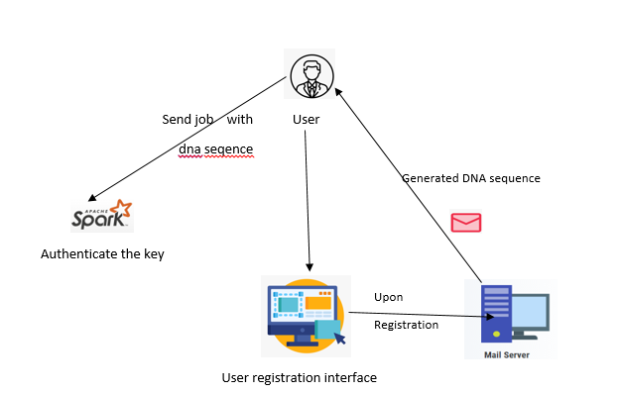

**5. Parameter Formulas:**

